# Requirement Elicitation

## System Description

System : Flight Book 4

Description : The Flight Booking System is a software application designed to make it easier for users to search, select, and book flight tickets online. This application provides up-to-date information about flight schedules, ticket prices, and the number of seats available from various airlines associated with the system. This application allows users to search for flights based on the city of origin and destination, as well as the date of departure. After the search results are displayed, users can select flights according to their needs and preferences, as well as view flight details such as class, ticket price, and number of available seats. In addition, users can also book flight tickets easily through this application. They can select an available class and seat number, and enter personal information such as name, phone number, and email address. After ordering a ticket, the user will receive a confirmation email containing flight information and an electronic ticket. This application is also equipped with a cancellation or change of ticket reservation feature, which can be done by the user through customer service or through the website. In addition, this application also provides information about airline policies regarding ticket cancellations and changes. With the features and services provided, the Flight Booking System is expected to facilitate users in ordering flight tickets online, increase efficiency in the reservation process, and improve user experience.

Author : Wahyu Andhyka

## Effort Analysis

Identify stakeholders : 10 minutes

Define the scope : 20 Minutes

Choose elicitation techniques : 10 Minutes

User Stories : 160 Minutes

Conceptual Model Diagrams : 30 Minutes

MockUp : 1000 Minutes

Define acceptance criteria : 60 Minutes

Total Work : 1290 Minutes

## Document Version

Version : 1

Date : March 16, 2023

Reference Documents : -

# Identify stakeholders

Activity : Identify stakeholders

Time needed : 10 minutes

Description : List all the individuals, groups, or organizations that will be affected by the project. This can include end users, project management, developers, and service providers.

List of stakeholders:

1. Customers: People who use the system to search and book flights.
2. Airline: Provides flight schedules and ticket prices that can be ordered through the system.
3. Regulator: Government organization that ensures that the flight booking system complies with applicable regulations and requirements, such as flight safety and consumer protection.

# Define the scope

Activity : Identify scope

Time needed : 20 minutes

Description : Defining the scope of needs elicitation by identifying the goals and objectives of the project. In this case, we need to review the reason for making the project and the ultimate goal to be achieved. Apart from that, we also need to define the vision and mission of the project to understand how the software will support the business goals.

Scope of the project:

1. Flight ticket search: The flight booking system allows customers to search for flight tickets based on schedules, prices, and routes.
2. Reservation and payment: The system must enable customers to make flight ticket reservations and payments through various available payment methods.
3. Confirmation and notification: After the customer makes a payment, the system must issue a confirmation and notification regarding the order and travel details.
4. Management of changes and cancellations: The system must allow customers to make changes to schedules or cancel flight ticket bookings.
5. Management of customer profiles: The system shall enable customers to manage their profiles, including personal information, preferences and travel history.
6. Integration with external systems: The flight booking system must be able to be integrated with external systems, such as flight systems, hotel systems, or local transportation systems.
7. Reporting and analysis: The system must be able to generate reports and analysis related to system performance and customer experience, such as reservation success rate, cancellation rate, and customer satisfaction.
8. Security and privacy: The system must ensure that customer and company data are securely protected from cyber-attacks and protect customer privacy.
9. Customer support: The system must provide adequate customer support, including a support ticket system and live customer service.
10. Scalability: The system must be able to handle a large number of users and increase capacity as needed.

# Choose elicitation techniques

Activity : Choose an elicitation technique

Time needed : 10 minutes

Description : To determine the appropriate elicitation technique, several things need to be considered: Understand the type of information to be collected. Pay attention to the preferences and comfort of users or stakeholders in choosing the right elicitation technique. Some elicitation techniques can be done in person, while others can be done online or over the phone. Paying attention to the expertise and experience of users or stakeholders in the matter to be discussed.

Stakeholders:

1. Stakeholder 1: Customers

Elicitation Techniques: Interviews, Observations, Questionnaires

1. Stakeholder 2: Airline

Elicitation Techniques: Observation, Document Analysis

1. Stakeholder 3: Regulators

Elicitation Techniques: Document Analysis

# User Stories

Activity : Telling the needs of users

Time needed : 160 Minutes

Description : User stories should describe the storyline from the user's perspective. Stories should follow logical steps and provide clear context. User stories must cover both functional and non-functional requirements. Functional requirements describe what the system needs to do, while non-functional requirements describe how the system should do it.

User Stories Stakeholder 1:

1. As a customer, you can easily and quickly search for available flights through the website or flight booking system application.
2. As a customer, I get a choice of flights at affordable prices and facilities that suit my needs.
3. As a customer, you get clear and accurate information about schedules, routes and flight changes.
4. As a customer, I can choose a seat that is comfortable and according to my preferences when booking flights.
5. As a customer, get order confirmation quickly and easily via email or flight booking system application.
6. As a customer, you can cancel or change flights easily and without additional fees if there is a change of plans.
7. As a customer I get responsive and helpful customer service in the event of a problem with my flight or booking.
8. As a customer, I can provide feedback about my experience using the flight booking system, and see improvements and improvements made based on that feedback.

User Stories Stakeholder 2:

1. As an airline, I can enter my flight schedule easily and quickly into the flight booking system.
2. As an airline, I can determine prices and special offers for my flights, and adjust these prices automatically in the flight booking system.
3. As an airline, I can track and manage the capacity and supply of seats on my flights through the flight booking system.
4. As an airline, I get accurate and up-to-date information about sales and booking of my flight tickets through the flight booking system.
5. As an airline, I can view customer reviews and feedback about my flights through the flight booking system, and take action to improve service quality if necessary.
6. As an airline, it obtains accurate data and analysis on ticket sales and flight trends through the flight booking system, and uses them to make the right business decisions.
7. As an airline, the flight booking system can be integrated with my airline's internal systems, such as the crew management system and flight management system, to facilitate management and reporting.

User Stories Stakeholder 3:

1. As a regulator, it ensures that the flight booking system complies with all applicable regulations and aviation safety standards.
2. As a regulator, it can monitor and verify flight performance reports and passenger data generated by the flight booking system.
3. As a regulator, it ensures that the flight booking system provides clear and accurate information about ticket prices and other costs, so consumers can make the right decision.
4. As a regulator, ensure that the flight booking system has an effective complaint and problem solving mechanism to protect consumer rights.
5. As a regulator, it can access and analyze data on the performance and behavior of the aviation industry generated by the flight booking system, to assist in formulating policies and making decisions.
6. As a regulator, it ensures that the flight booking system can accommodate the needs of consumers who require special services, such as wheelchairs or special meals.
7. As a regulator, it ensures that the flight booking system promotes healthy and fair business practices, including in terms of competition and consumer protection.

# Conceptual Model Diagrams

Activity : Conceptual Diagrams

Time needed : 30 minutes

Description : Identify the important elements in the system or process that you want to describe in the diagram, determine the relationship between these elements. Check the consistency and completeness of the diagram to ensure that all elements and relationships are drawn correctly.

Conceptual Diagrams:

# MockUps

Activity : Mockups

Time needed : 1000 Minutes

Description : A mockup activity aims to help conceptualize ideas and show how a product or system will look and behave in the early stages of development, involving the creation of sketches, wireframes, or simple interactive prototypes that represent the main elements that will be present in the product or system, the appearance of the user interface, layout, layout of the elements, and setting the color, font, and size.

Mockups:

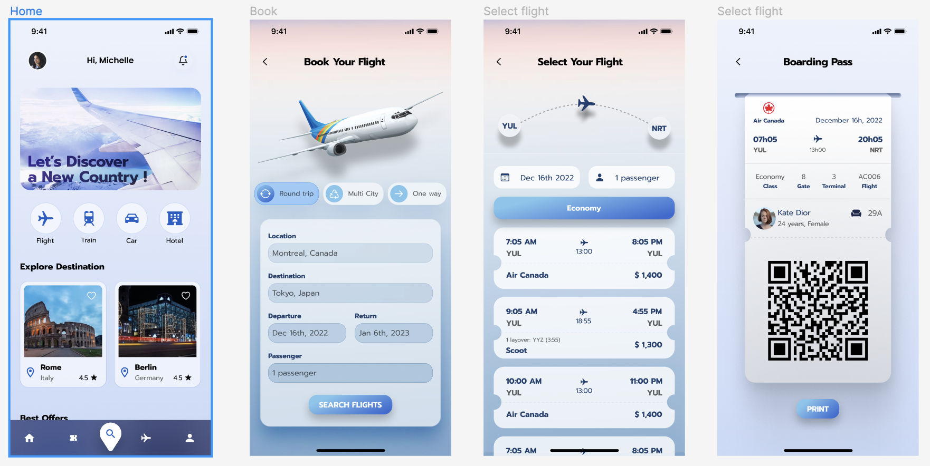

Mockup Links: [https://www.figma.com/file/vxPTs5Agj6zJFYsI5lJkFw/Flight-app- ( Community)?node-id=0%3A1&t=2bCnRqKQmS3osq62-1](https://www.figma.com/file/vxPTs5Agj6zJFYsI5lJkFw/Flight-app-(Community)?node-id=0%3A1&t=2bCnRqKQmS3osq62-1)

# Define acceptance criteria

|  |  |  |  |  |  |
| --- | --- | --- | --- | --- | --- |
| Activity: Define acceptance criteria | | | Time needed: 60 Minutes | | |
| Acceptance criteria are standards or criteria that must be met in order for a product or system to be considered successful and acceptable to users or customers. The acceptance criteria must cover all aspects that are important to the user and meet the defined limits and parameters. | | | | | |
| **Positive Case** | | | | | |
| Given that |  | | | UserInterface | Note |
| when | Then | |
| The user opens the application | Pressing the Flight icon | The application displays the Book page  Location   * Type: Strings * Minimum: 3 Characters * Maximum: 100 Characters * Dropdown appears * Required   destinations   * Type: Strings * Minimum: 3 Characters * Maximum: 100 Characters * Dropdown appears * Required   Departure   * Type: Dates * A date selection pop-up appears * Required   return   * Type: Dates * A date selection pop-up appears   Passengers   * Type: Numerical * Minimum: Number 1 * Maximum: Number 5 * Required | |  |  |
|  |  |  | |  |  |
| **Negative Case** | | | | | |
| Given that |  | | | UserInterface | Note |
| when | Then | |
| The user is on the booking page | The user entered the wrong destination | The system displays a notification | |  |  |
|  |  |  | |  |  |

# Working Documentation Appendix



Interview Video Link: <https://drive.google.com/file/d/1iT4GWV2jClqHuWHgtmCgoVbhGZQdcPKB/view?usp=sharing>



Mockup Testing Video Link: <https://drive.google.com/file/d/1iT4GWV2jClqHuWHgtmCgoVbhGZQdcPKB/view?usp=sharing>